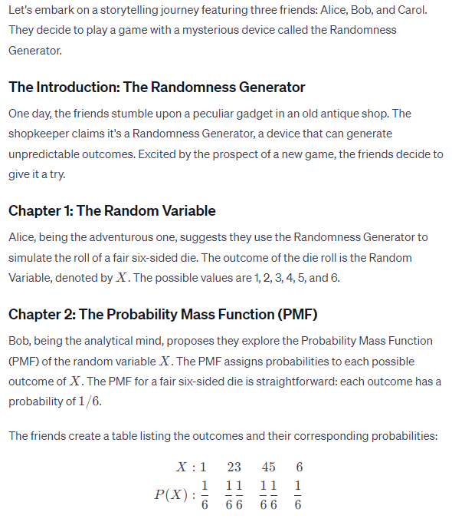
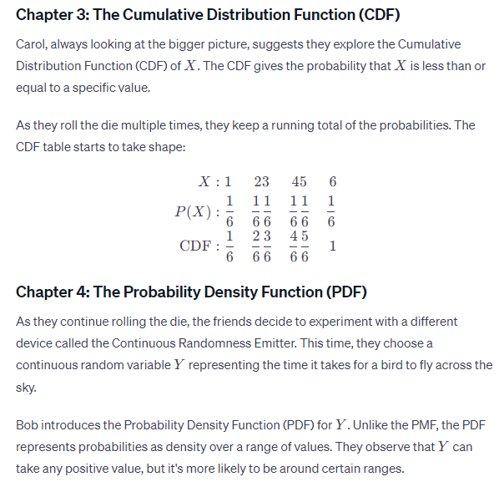
The Conclusion: Wrapping Up the Adventure
The friends, through their exploration of random variables, PMFs, CDFs, and PDFs, have gained a deeper understanding of randomness. They realize that these concepts are powerful tools for describing and understanding uncertain outcomes, whether discrete or continuous.
As they leave the antique shop, they can't help but appreciate the beauty of randomness and the mathematical elegance that helps make sense of it all. The friends, armed with their newfound knowledge, embark on more adventures, ready to tackle the mysteries of probability and chance.
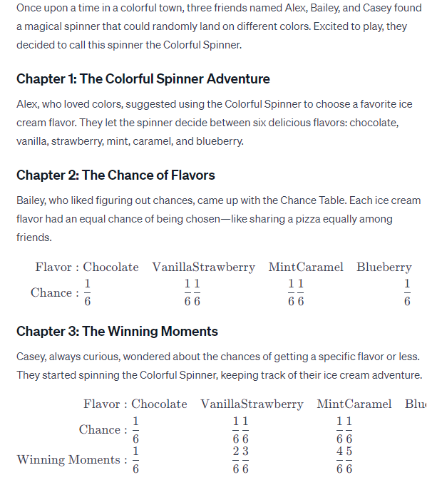
Chapter 4: The Sweet Time Continues
The friends decided to switch things up and use a Magic Timer for the next adventure. They wanted to know how long it took for a butterfly to flutter by. Casey introduced the Magic Timer with its magical ability to capture time.
The Conclusion: The Magical Adventures Continue
As the friends played with the Colorful Spinner and the Magic Timer, they discovered that numbers and chance could make everyday adventures even more magical. They realized that understanding chances and time could add a sprinkle of excitement to their lives.

With smiles on their faces, Alex, Bailey, and Casey continued their magical adventures, always ready for the next surprise the Colorful Spinner and the Magic Timer had in store for them. And so, the story of their colorful and whimsical town continued, filled with ice cream delights and fluttering butterflies.

